The following is the output from applying the groupby method. How many different groups are there?

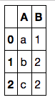



1



3



2

1 point